`



**COMP1640 Enterprise Web Software Development**

**Group Report**

Tutor:

Name: Lieu Huynh

Email:

Class:

|  |  |
| --- | --- |
| Team Name | Group |
| Team members | Nguyen Viet Thang: Programmer  Lieu Huynh: Scrum Master  Nguyen Thien Tri: Database Design  Hua Minh Quan: Tester  Nguyen Thanh Tuong: Web design  Nguyen Truong Duy: Programmer |

Table of Contents

1/ Introduction: 3

Project Introduction: 3

Introduction about Scrum: 3

2/ Agile Scrum documentation: 5

a. Roles: 5

b. Tools: 5

c. Product backlog 6

d. Meetings 8

1. Sprint planning 8

2. Daily Scrum: 13

3. Sprint review 14

3/ Design documentation: 17

Use case: 17

Database design 21

Wireframe 21

4/ Testing 38

Test plan 38

Test log 38

Test Screenshot 38

5/ Evaluation: 38

Challenges: 38

System weaknesses: 38

System Strengths 38

Learning outcomes. 38

# 1/ Introduction:

In the Currently in universities, in addition to the direct teaching programs that have been popular for a long time, in recent years, there is a method that has been tested and brought great effect, it saves money and time and the effort of the learner but still helps students to have the full knowledge as traditional learning that is e-learning. These e-learning courses make it easy for students to learn via the internet and do not need to go to class. Although e-learning has many good aspects and can help students and teachers in online learning, but it still has certain limitations such as attendance of students through the e-learning system, storage of teachers' lectures. through each lesson, the contact between the teacher and the student or the school and the teacher, the scheduling of the student's schedule when the teacher unexpectedly leaves, the arrangement of the teacher's schedule when the student requests a change the lesson ... Based on these issues, we will create an online learning website called e-tutor, the purpose of this website is to solve problems in online learning and to help online learning should be more common and feasible in the future.

## Introduction about Scrum:

**Scrum**

We made this website in groups and for the team to be most effective and efficient, we chose the Scrum model to apply to this project.

Scrum framework haves 3 core values: transparency, inspection and adaptation.

**Transparency**

All problems and difficulties must be transparent, the information must be clear among group members. The work schedule must be updated regularly, difficulties and solutions must also be made public and constantly updated for everyone in the group and customers to update. Each member of the team needs to understand his or her role to make the work progress more smoothly. There will be meetings held each week to track the progress of the work.

**Inspection**

The project must be updated and checked every week, the purpose of this is to keep up with the problems and fix them as quickly as possible. Testing also assesses the quality of the product in each stage and is the starting mechanism for adaptation and improvements in Scrum.

**Adaptation**

This is a flexible form of adaptation that improves the project development's ability to adapt based on publicly available team data and tests. This helps improve the efficiency of the project.

**Roles in Scrum:**

**Product owner**

Product owner is the person responsible for the product and the project, who determines whether the project is operational or not.

**Development Team**

Development team has a project development role, they will rely on the backlogs to put into functions in the product, they work together and manage themselves.

**Scrum Master**

The Scrum master acts as the manager of small groups in Scrum, they will help to revise the people in the team and communicate among the team members, ensuring people work well in the Scrum model.

**Sprint:**

**Planning**: Create a plan of functions based on the needs of the project, consult project information. Assessing the complexity and time to complete the project. The scrum model allows the plan to be changed and adjusted based on the circumstances of the project development so it is flexible in project development for developers.

**Review:** After planning the group will review the plan and expose any problems encountered during the project implementation.

**Retrospective:** Develop a project based on the plan and work with the scrum master to find ways to solve problems and improve the product.

**Daily Scrum:** Each day, the scrum master will meet with the production team about 30 minutes to update the work progress, share information and difficulties encountered during product development.

**Tools of Scrum:**

**Product backlog:** The product backlog is a list of functions made based on the priority of each function in the project. The product owner will be able to identify these items.

**Sprint backlog:** The sprint backlog is a dash planning, after getting the product backlog from the product owner, the team will break down the conditions based on the priority from high to low and consider the problems in that product backlog to make a working plan..

**Burndown chart:** The Burndown chart is a type of run arrangement, it is formed based on a meeting between the product owner and the development team, and team will rely on high to low functions and check the conditions to raise issues as a list commitment. The Burndown chart is used to track sprint progress and it is used as a scrum standard and is widely used for its usefulness value.

# 2/ Agile Scrum documentation:

1. Roles:

Roles of each member in team:

Nguyen Viet Thang: Programmer

Lieu Huynh: Scrum Master

Nguyen Thien Tri: Database Design

Hua Minh Quan: Tester

Nguyen Thanh Tuong: Web design

Nguyen Truong Duy: Programmer

1. Tools:

The tools of Agile Scrum will be used:

Agile Scrum tools:  
- Product Backlog: Write down the requirements in the application.  
- Sprint Backlog: the stages and tasks in each sprint  
- Burndown Chart: Representing the process of group activities

1. Product backlog

<https://trello.com/b/zlt5Qpw5/comp1640-enterprise-web-softw>

**As a student**

As a student, I need to have a system for communicating and exchanging information with teachers.

As a Student, I need to have a system for organizing meetings

As a Student, I need to have a system for uploading documents

As a Student, I need to have a system of review of resources

As a Student, I need to have a blogging system

As a Student, I need to have an email system to send teachers  
As a Student, I can email to teacher about is to be used only for notification of events recorded in the backend database

As a Student, I need the interface must be suitable for mobile phones, tablets, desktops

**As a tutor**

As a tutor, I need to have a system for communicating and exchanging information with teachers.

As a tutor, I need to have a system for organizing meetings

As a tutor, I need to have a system for uploading documents

As a tutor, I need to have a system of review of system

As a tutor, I need to have a blogging system

As a tutor, I need a personal calendar to be able to be placed in classes that fit their schedule

As a tutor, I need to have an email system to send students

As a tutor, I need Teachers can email students about is to be used only for notification of events recorded in the backend database

As a tutor, I need the interface must be suitable for mobile phones, tablets, desktops

**As an admin**

As an admin, I need Authorised staff will have access to the dashboards of other staff, and to individual dashboards for students.

As an admin, I need Student and staff data is accessed from the university MIS system. The maintenance of this is outside the scope of this project.

As an admin, I need Admin can assign rights to tutors and cancel their rights for students

As an admin, I need Students and tutors will receive notification emails if there is a change in student or tutor

As an admin, I need Admin can allocate a large number of students at the same time to 1 teacher

As an admin, I need admin can cancel many student at a time in a teacher's classroom

As an admin, I need the interface must be suitable for mobile phones, tablets, desktops

**Activities**

**Student**

* All students and their tutors are to use the eTutor system for messaging, arranging and recording meetings (both real and virtual), uploading documents and commenting on them, and for blogging.
* All students must have a personal tutor
* Each student will have their own personal dashboard summarising their interaction with their personal tutor.
* Email between students and their personal tutors is to be used only for notification of events recorded in the backend database. No other content is to be sent via email
* The interface must be suitable for all devices (eg mobile phones, tablets, desktops)

**Tutor**

* All students and their tutors are to use the eTutor system for messaging, arranging and recording meetings (both real and virtual), uploading documents and commenting on them, and for blogging.
* Each tutor will have a personal calendar to be able to be placed in classes that fit their schedule
* Email between students and their personal tutors is to be used only for notification of events recorded in the backend database. No other content is to be sent via email.
* The interface must be suitable for all devices (eg mobile phones, tablets, desktops)

**Admin**

* Any authorised member of staff can allocate or reallocate personal tutors to students. The student and the personal tutors will get notification emails when this happens.
* Bulk allocation of students to their personal tutor (eg 10 at a time) needs to be implemented.
* Authorised staff will have access to the dashboards of other staff, and to individual dashboards for students.
* Student and staff data is accessed from the university MIS system. The maintenance of this is outside the scope of this project.

1. Meetings
2. Sprint planning

**Sprint 1:**

Located: Coffee Shop

Day: 1-3 -2020

Time: 9.00 AM

**Attendance**

Nguyen Viet Thang: Programmer

Lieu Huynh: Scrum Master

Nguyen Thien Tri: Database Design

Hua Minh Quan: Tester

Nguyen Thanh Tuong: Web design

Nguyen Truong Duy: Programmer

**Agenda**

* Discuss and make task to be performed

Lieu Huynh: We must to create database first, next we create login form and register after that we create interface of this app.

All member: Agree

* Time to develop

Nguyen Viet Thang: We will create database from 2/3/2020 to 7/3/2020 , next we will create login form and register from 8/3/2020 to 10/3/2020 and we create interface from 11/3/2020 to 14/3/2020

All member: Agree

* Role of each member in team.

Nguyen Thien Tri: I will create database

Nguyen Thanh Tuong: I will design interface

Nguyen Viet Thang, Nguyen Truong Duy: I will create login and register

Lieu Huynh: I will review database

Hua Minh Quan: I will test login and register functions.

* Task for each member

Nguyen Thien Tri: Create database

Nguyen Thanh Tuong: Design interface

Nguyen Viet Thang, Nguyen Truong Duy: Create login and register

Lieu Huynh: Review database

Hua Minh Quan: Test login and register functions.

* Execution Time

Create database from 2/3/2020 to 7/3/2020

Create login form and register from 8/3/2020 to 10/3/2020

Create interface from 11/3/2020 to 14/3/2020

Test and review 14/3/2020 – 15/3/2020

* End Time: 11h00 AM.

Spring Backlog of Sprint 1:

|  |  |  |  |  |  |  |  |  |
| --- | --- | --- | --- | --- | --- | --- | --- | --- |
| Sprint 1 | Point | Dev’s  Name | Begin | End | Act Begin | Act End | Act Point | Notes |
| Create database | 4 | Nguyen Thien Tri | 2/3/2020 | 7/3/2020 |  |  |  |  |
| Create login form and register from | 3 | Nguyen Viet Thang, Nguyen Truong Duy | 11/3/2020 | 10/3/2020 |  |  |  |  |
| Create interface | 3 | Nguyen Thanh Tuong | 11/3/2020 | 14/3/2020 |  |  |  |  |
| Test and review and test login | 2 | Hua Minh Quan, Liu Huỳnh | 14/3/2020 | 15/3/2020 |  |  |  |  |

**Sprint 2:**

Located: Coffee Shop

Day: 15/3/2020

Time: 9.00 AM

**Attendance**

Nguyen Viet Thang: Programmer

Lieu Huynh: Scrum Master

Nguyen Thien Tri: Database Design

Hua Minh Quan: Tester

Nguyen Thanh Tuong: Web design

Nguyen Truong Duy: Programmer

**Agenda**

* Discuss and make task to be performed

Lieu Huynh: We must to analysis requirement in outline and proceed it with 1-4 level for each user like student, tutor, admin. After that we design maintenance data, analysis system, create decentralization system.

All member: Agree

* Time to develop

Nguyen Thien Tri: We will proceed function with 1-4 level for each user from 15/3/2020 to 30/3/2020 , next we will design maintenance data from 1/4/2020 to 2/4/2020 and we create analysis system from 3/4/2020 to 4/4/2020 after that we create decentralization system from 5/4/2020 to 6/4/2020

All member: Agree

* Role of each member in team.

Nguyen Viet Thang, Nguyen Truong Duy: I will proceed function with 1-4 level for Student

Nguyen Thien Tri: I will design maintenance data

Nguyen Thanh Tuong: I will create analysis system

Lieu Huynh: I will decentralization system

Hua Minh Quan: I will proceed function with 1-4 level for tutor and admin.

* Task for each member

Nguyen Viet Thang, Nguyen Truong Duy: Proceed function with 1-4 level for Student

Nguyen Thien Tri: Design maintenance data

Nguyen Thanh Tuong: Create analysis system

Lieu Huynh: Decentralization system

Hua Minh Quan: Proceed function with 1-4 level for tutor and admin.

* Execution Time

Proceed function with 1-4 level for each user from 15/3/2020 to 30/3/2020

Design maintenance data from 1/4/2020 to 2/4/2020

Analysis system from 3/4/2020 to 4/4/2020

Create decentralization system from 5/4/2020 to 6/4/2020

* End Time: 11h00 AM.

Sprint Backlog of Sprint 2:

|  |  |  |  |  |  |  |  |  |
| --- | --- | --- | --- | --- | --- | --- | --- | --- |
| Sprint 2 | Point | Dev’s  Name | Begin | End | Act Begin | Act End | Act Point | Notes |
| Proceed function with 1-4 level for Student | 4 | Nguyen Viet Thang, Nguyen Truong Duy | 15/3/2020 | 30/3/2020 |  |  |  |  |
| Design maintenance data | 3 | Nguyen Thien Tri | 11/3/2020 | 10/3/2020 |  |  |  |  |
| Analysis system | 3 | Nguyen Thanh Tuong | 1/4/2020 | 2/4/2020 |  |  |  |  |
| Create decentralization system | 4 | Lieu Huynh | 3/4/2020 | 4/4/2020 |  |  |  |  |
| Proceed function with 1-4 level for tutor and admin. | 4 | Hua Minh Quan | 15/3/2020 | 30/3/2020 |  |  |  |  |

Sprint 3:

Located: Coffee Shop

Day: 15/3/2020

Time: 9.00 AM

**Attendance**

Nguyen Viet Thang: Programmer

Lieu Huynh: Scrum Master

Nguyen Thien Tri: Database Design

Hua Minh Quan: Tester

Nguyen Thanh Tuong: Web design

Nguyen Truong Duy: Programmer

**Agenda**

* Discuss and make task to be performed

Lieu Huynh: This sprint mission is perform IDs from 5-8, create date and time format, create email system for tutor and student, create account for student, create email system work, create account for tutor. Write document, upload system, blog system.

All member: Agree

* Time to develop

Hua Minh Quan: This sprint mission is perform IDs from 5-8, create date and time format from 4/4/2020 to 5/4/2020, create email system for tutor and student 4/4/2020 to 5/4/2020, create account for student 4/4/2020 to 5/4/2020, create email system work 4/4/2020 to 5/4/2020, create account for tutor 4/4/2020 to 5/4/2020.

All member: Agree

* Role of each member in team.

Nguyen Viet Thang: I will create date and time format

Nguyen Thien Tri: I will create account for student and tutor

Nguyen Thanh Tuong: I will create email system for tutor and student

Nguyen Truong Duy: I will create upload system, blog system and Write document.

Hua Minh Quan: I will Test and review.

* Task for each member

Nguyen Viet Thang: Create date and time format

Nguyen Thien Tri: Create account for student and tutor

Nguyen Thanh Tuong: Create email system for tutor and student

Nguyen Truong Duy: create upload system, blog system and Write document

Hua Minh Quan: Test and review.

* Execution Time

Create date and time format from 4/4/2020 to 5/4/2020

Create email system for tutor and student 4/4/2020 to 5/4/2020

Create account for student 4/4/2020 to 5/4/2020

Create upload system, blog system and Write document 4/4/2020 to 10/4/2020

Create account for tutor 4/4/2020 to 5/4/2020.

End Time: 11h00 AM.

Sprint Backlog of Sprint 3:

|  |  |  |  |  |  |  |  |  |
| --- | --- | --- | --- | --- | --- | --- | --- | --- |
| Sprint 3 | Point | Dev’s  Name | Begin | End | Act Begin | Act End | Act Point | Notes |
| Create date and time format | 5 | Nguyen Viet Thang | 4/4/2020 | 5/4/2020 |  |  |  |  |
| Create account for student and tutor | 5 | Nguyen Thien Tri | 4/4/2020 | 5/4/2020 |  |  |  |  |
| Create email system for tutor and student | 3 | Nguyen Thanh Tuong | 4/4/2020 | 5/4/2020 |  |  |  |  |
| Create upload system, blog system and Write document | 4 | Nguyen Truong Duy | 4/4/2020 | 10/4/2020 |  |  |  |  |
| Test and review. | 4 | Hua Minh Quan | 4/4/2020 | 5/4/2020 |  |  |  |  |

1. **Daily Scrum**:

Our team exchanged information on ZALO, we talked about the difficulties as well as solutions to those difficulties to ensure the plan in each sprint. In addition to exchanging on ZALO, we have meetings meet face-to-face with each week in a coffee shop as well as in the classroom, at which point the team members will directly share their issues and help other friends. All activities is make sure the project will be on schedule.

1. **Sprint review**

The Sprint Review Meeting is a used to review about performance of that Sprint.

Sprint 1:

Sprint 1 evaluation:

|  |  |  |  |  |  |  |  |  |
| --- | --- | --- | --- | --- | --- | --- | --- | --- |
| Sprint 1 | Point | Dev’s  Name | Begin | End | Act Begin | Act End | Act Point | Notes |
| Create database | 4 | Nguyen Thien Tri | 2/3/2020 | 7/3/2020 | 2/3/2020 | 7/3/2020 | 4 |  |
| Create login form and register from | 3 | Nguyen Viet Thang, Nguyen Truong Duy | 11/3/2020 | 10/3/2020 | 11/3/2020 | 10/3/2020 | 5 |  |
| Create interface | 3 | Nguyen Thanh Tuong | 11/3/2020 | 14/3/2020 | 11/3/2020 | 14/3/2020 | 4 |  |
| Test and review | 2 | Hua Minh Quan, Liu Huỳnh | 14/3/2020 | 15/3/2020 | 14/3/2020 | 15/3/2020 | 5 |  |

Review:

All stories set out to be completed on time in the plan, all tasks are completed.

Sprint 2:

Sprint 2 evaluation:

|  |  |  |  |  |  |  |  |  |
| --- | --- | --- | --- | --- | --- | --- | --- | --- |
| Sprint 2 | Point | Dev’s  Name | Begin | End | Act Begin | Act End | Act Point | Notes |
| Proceed function with 1-4 level for Student | 4 | Nguyen Viet Thang, Nguyen Truong Duy | 15/3/2020 | 30/3/2020 | 15/3/2020 | 30/3/2020 | 5 |  |
| Design maintenance data | 3 | Nguyen Thien Tri | 11/3/2020 | 10/3/2020 | 11/3/2020 | 10/3/2020 | 4 |  |
| Analysis system | 3 | Nguyen Thanh Tuong | 1/4/2020 | 2/4/2020 | 1/4/2020 | 2/4/2020 | 4 |  |
| Create decentralization system | 4 | Lieu Huynh | 3/4/2020 | 4/4/2020 | 3/4/2020 | 4/4/2020 | 3 |  |
| Proceed function with 1-4 level for tutor and admin. | 4 | Hua Minh Quan | 15/3/2020 | 30/3/2020 | 15/3/2020 | 30/3/2020 | 4 |  |

Review:

There were some problems in sprint 2 that made progress at some stage delayed but it was still on schedule and all tasks assigned were completed on schedule.

Sprint 3:

Sprint 3 evaluation:

|  |  |  |  |  |  |  |  |  |
| --- | --- | --- | --- | --- | --- | --- | --- | --- |
| Sprint 3 | Point | Dev’s  Name | Begin | End | Act Begin | Act End | Act Point | Notes |
| Create date and time format | 5 | Nguyen Viet Thang | 4/4/2020 | 5/4/2020 | 4/4/2020 | 5/4/2020 | 5 |  |
| Create account for student and tutor | 5 | Nguyen Thien Tri | 4/4/2020 | 5/4/2020 | 4/4/2020 | 5/4/2020 | 4 |  |
| Create email system for tutor and student | 3 | Nguyen Thanh Tuong | 4/4/2020 | 5/4/2020 | 4/4/2020 | 5/4/2020 | 5 |  |
| Create upload system, blog system and Write document | 4 | Nguyen Truong Duy | 4/4/2020 | 10/4/2020 | 4/4/2020 | 10/4/2020 | 3 |  |
| Test and review. | 4 | Hua Minh Quan | 4/4/2020 | 5/4/2020 | 4/4/2020 | 5/4/2020 | 4 |  |

Review:

In sprint 3, there were a lot of technical difficulties, there were problems we didn't know how to solve, and it took a lot of time, it made the time a little bit ahead of schedule, but we Completed all tasks with help from the instructor. I think with the scrum model, time flexibility has been applied and has helped us to accomplish all the goals.

Conclusions:

There are many factors affecting the project, but most have been resolved. Yes, we have exceeded the deadline for personal and collective reasons but in the end, we have completed all the goals quite well.

1. Project Burn down chart

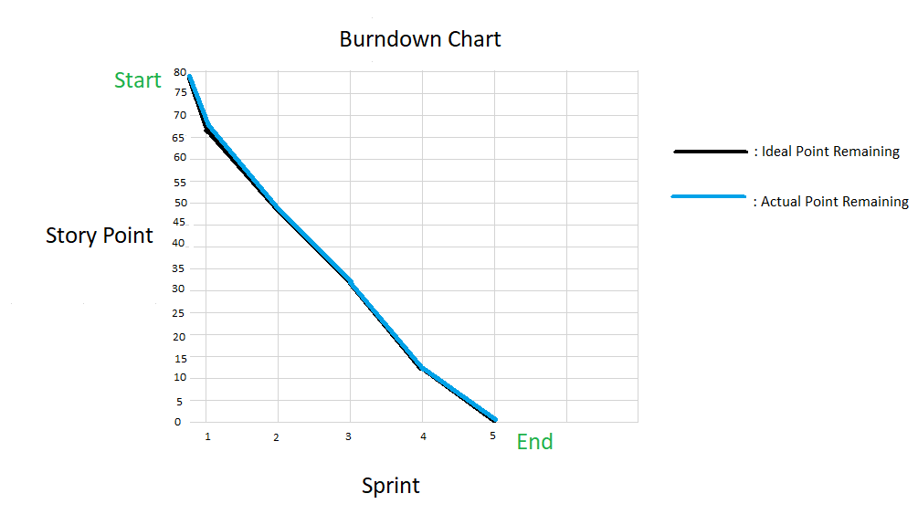

Figure: Burndown Chart

Description:

Burndown chart is a chart that helps our team to track the progress of the project, the vertical axis of the chart will be the stories listed at each sprint and start at 78, the horizontal axis of the chart is the deadlines set. , the black line shows the planned process and the blue line is the actual process. After each sprint the score will decrease and the chart will tend to go down, which is the reason for the burndown chart name.

# 3/ Design documentation:

## Use case:

Admin:

Figure: Use case for Admin 

Description:

* As an admin, I need Authorised staff will have access to the dashboards of other staff, and to individual dashboards for students.
* As an admin, I need Student and staff data is accessed from the university MIS system. The maintenance of this is outside the scope of this project.
* As an admin, I need Admin can assign rights to tutors and cancel their rights for students
* As an admin, I need Students and tutors will receive notification emails if there is a change in student or tutor
* As an admin, I need Admin can allocate a large number of students at the same time to 1 teacher
* As an admin, I need admin can cancel many student at a time in a teacher's classroom
* As an admin, I need the interface must be suitable for mobile phones, tablets, desktops Information.

**Tutor**:



Figure: Use case for tutor

Description:

* As a tutor, I need to have a system for communicating and exchanging information with student.
* As a tutor, I need to have a system for organizing meetings
* As a tutor, I need to have a system for uploading documents
* As a tutor, I need to have a system of review of system
* As a tutor, I need to have a blogging system
* As a tutor, I need a personal calendar to be able to be placed in classes that fit their schedule
* As a tutor, I need to have an email system to send students
* As a tutor, I need Teachers can email students about is to be used only for notification of events recorded in the backend database
* As a tutor, I need the interface must be suitable for mobile phones, tablets, desktops

**Student:**



Figure: Use case for Student

Description:

* As a student, I need to have a system for communicating and exchanging information with teachers.
* As a Student, I need to have a system for organizing meetings
* As a Student, I need to have a system for uploading documents
* As a Student, I need to have a system of review of resources
* As a Student, I need to have a blogging system
* As a Student, I need to have an email system to send teachers
* As a Student, I can email to teacher about is to be used only for notification of events recorded in the backend database
* As a Student, I need the interface must be suitable for mobile phones, tablets, desktops

## Database design

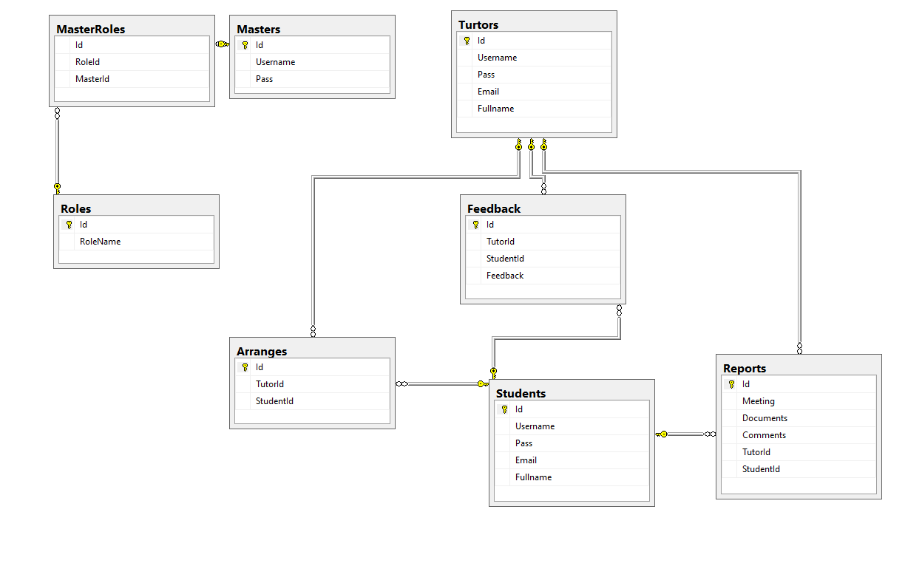

Figure: Entity Relationship Diagram.

Description:

This is the relationship between tables, the master role will be linked to the master and the master role through the ID with the n-n link.

Students and tutors are linked together through arranges and n-n relations. Students, reports and tutors are linked together in an n-n connection .UTor, feedback and students are linked together in n-n links.

.

## Wireframe

1. **Student**
2. Home page

Wireframe:

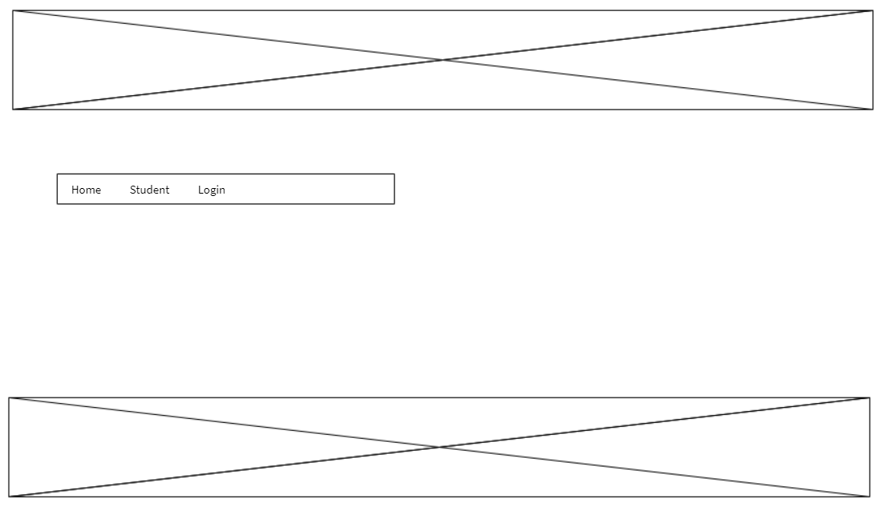

Reality:

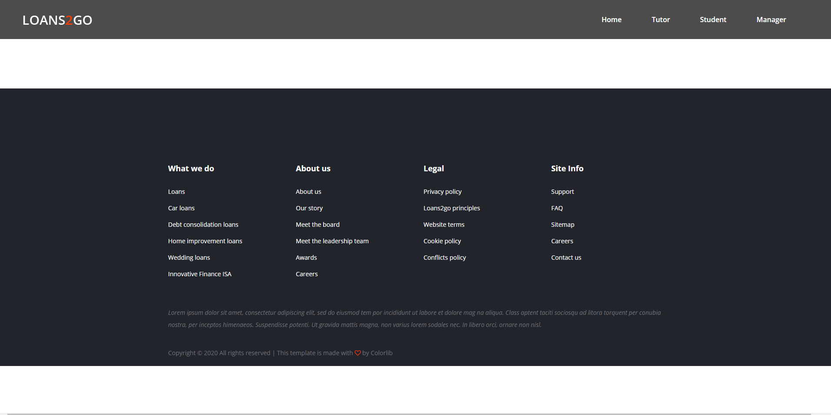

1. Register Page for Student

Wireframe:

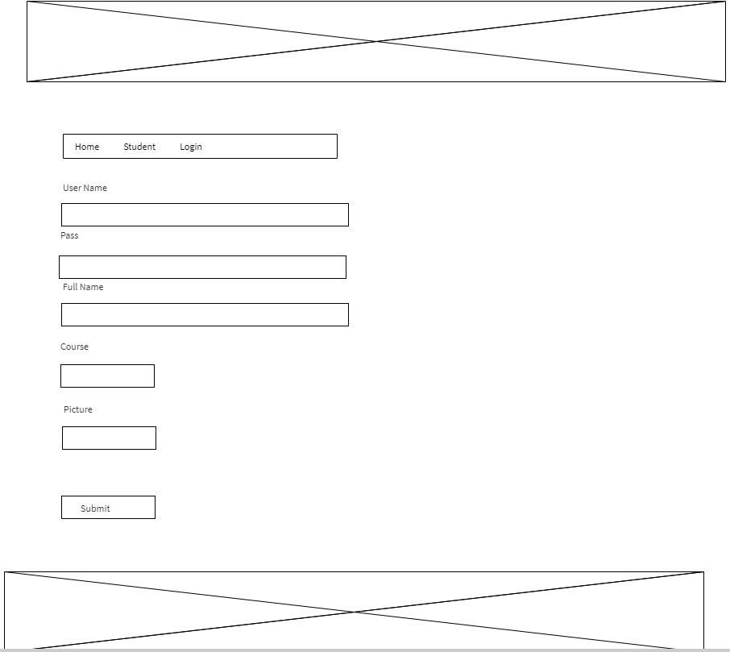

Reality:

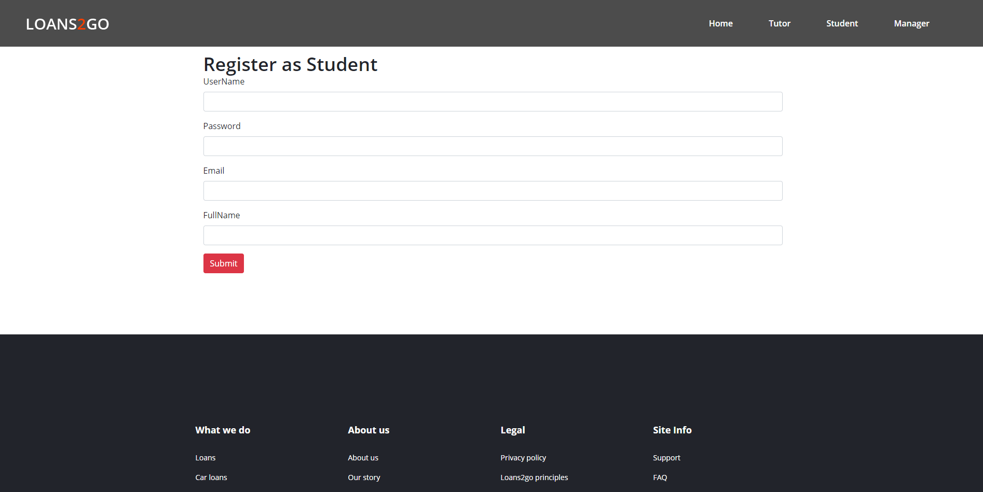

1. Login page as Student

Wireframe:

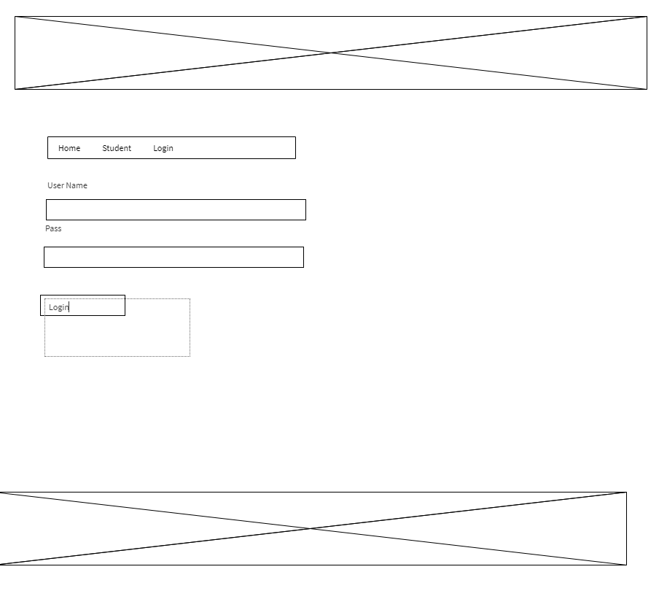

Reality:

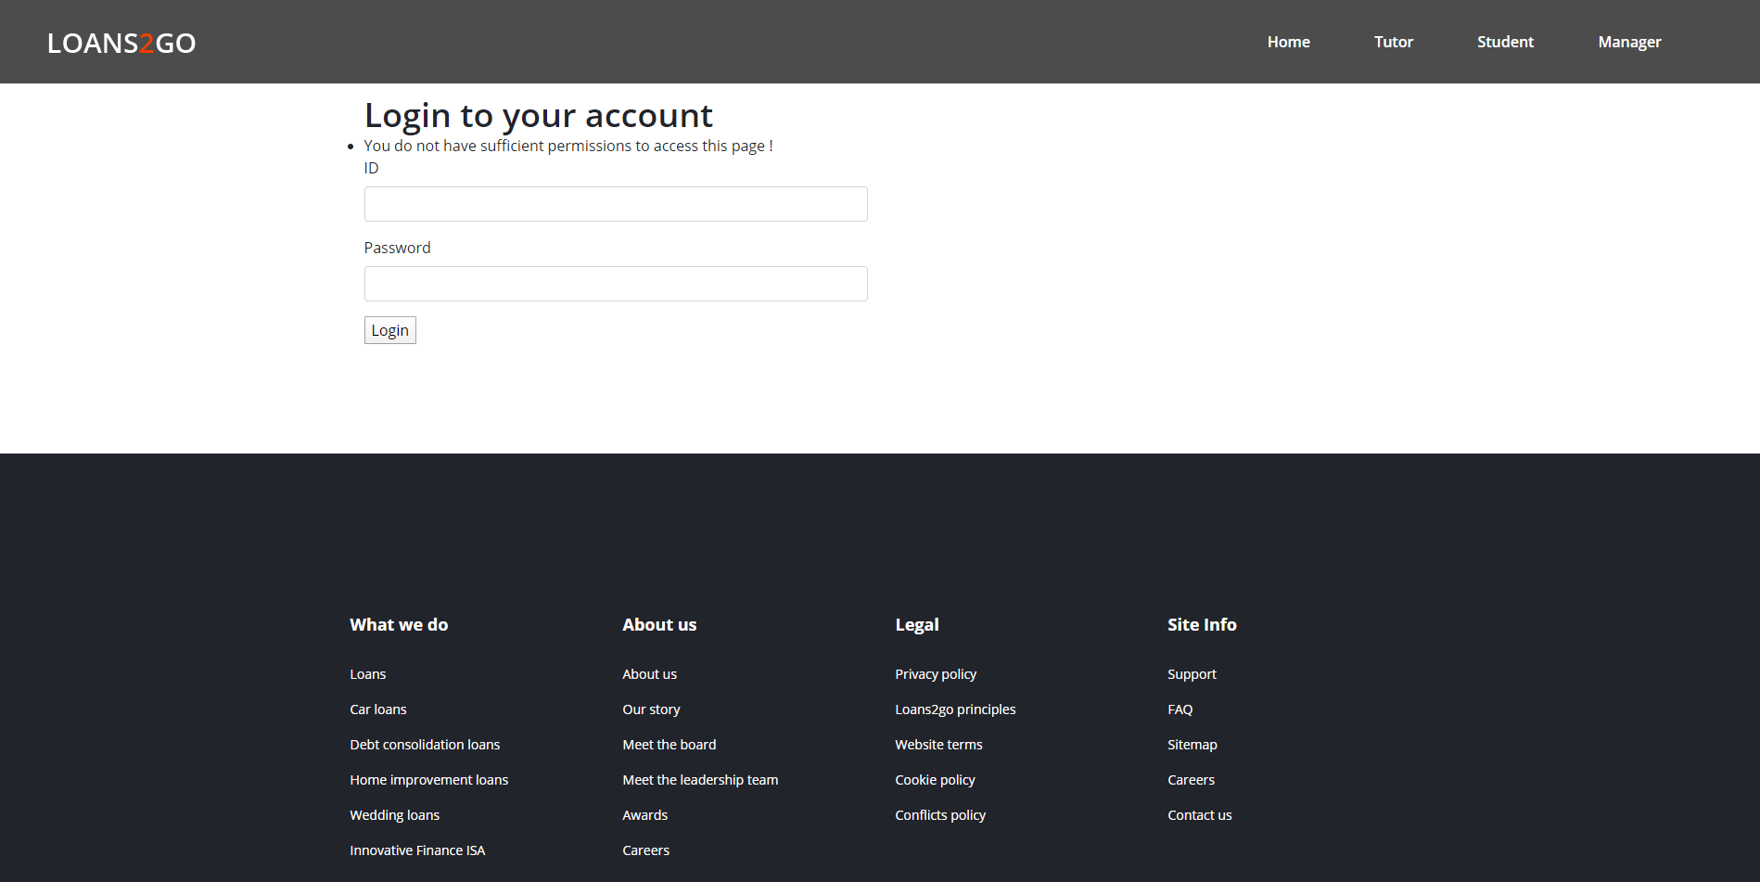

1. Post feedback

Wireframe:

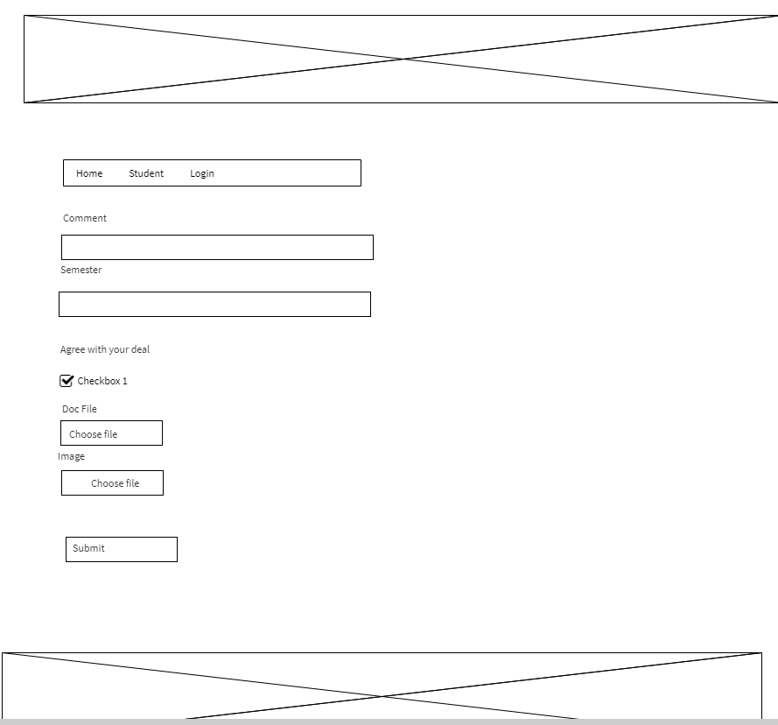

Reality:

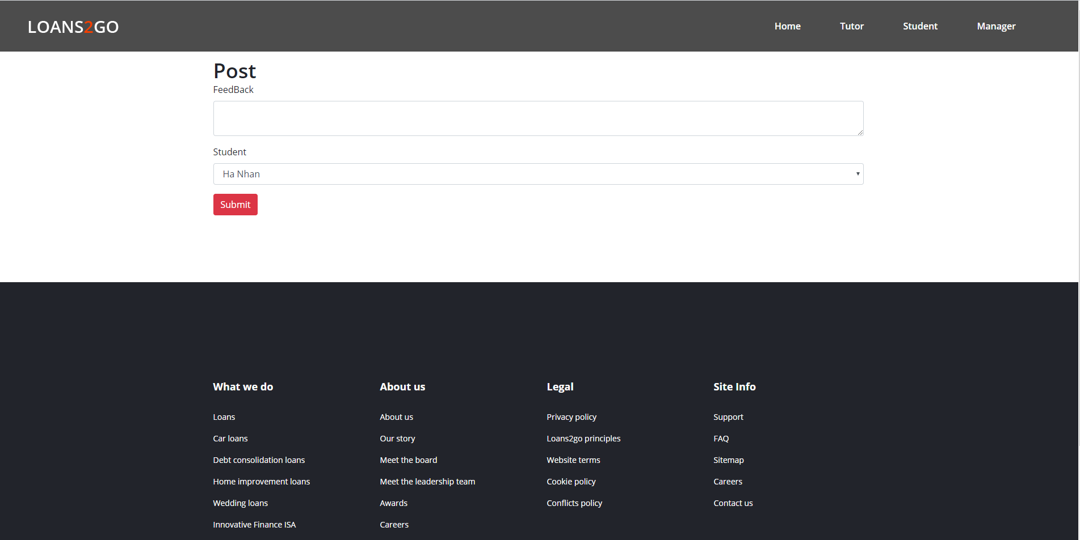

1. **Tutor**

Register Page for tutor

Wireframe:



Reality:

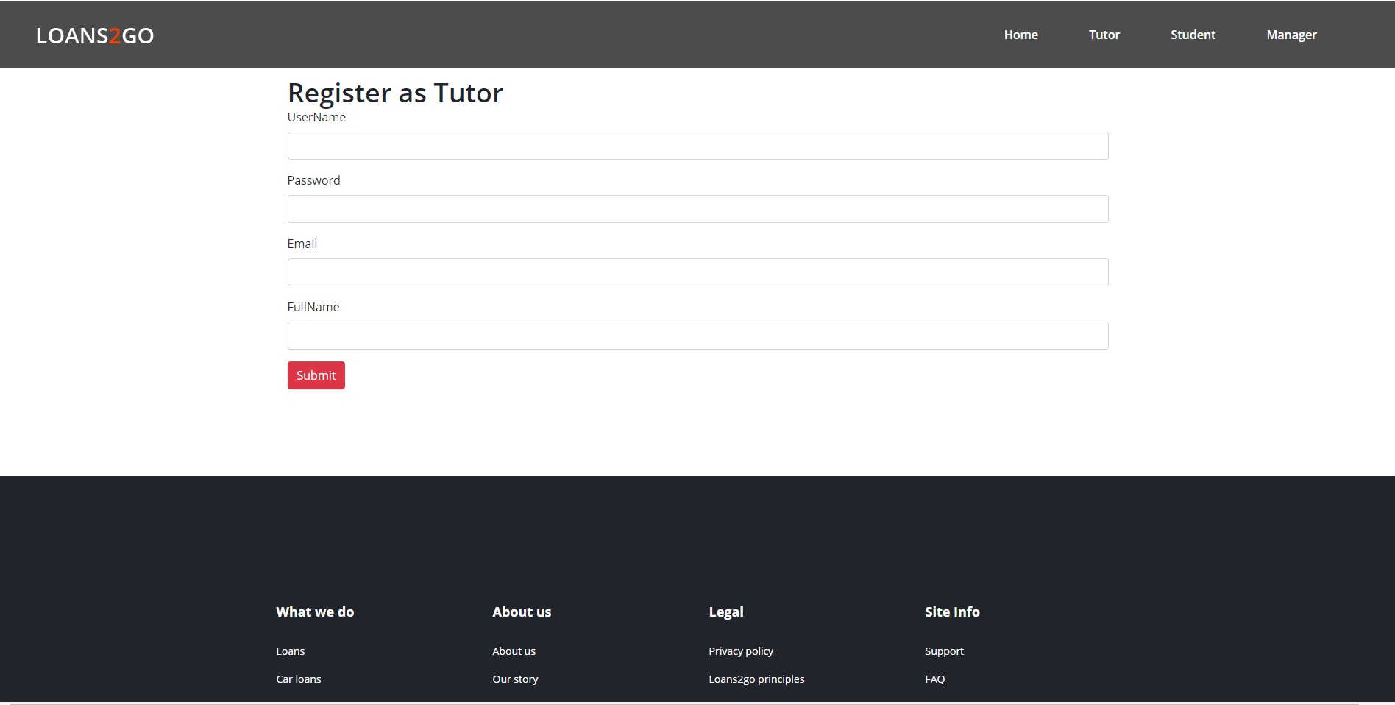

1. Login page as tutor

Wireframe:



Reality:

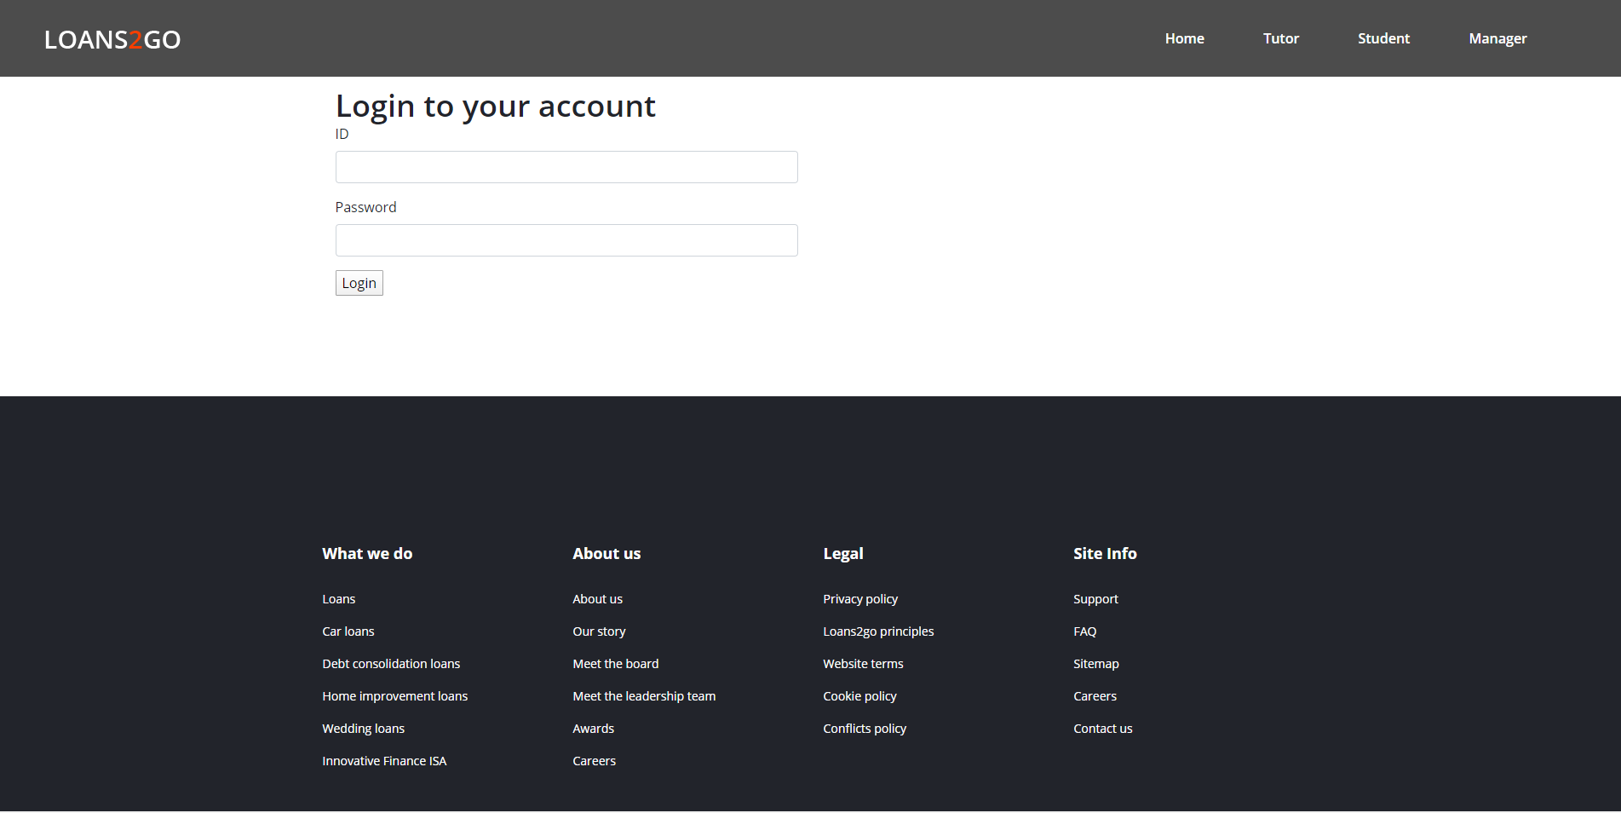

1. Post document for tutor

Wireframe:



Reality:

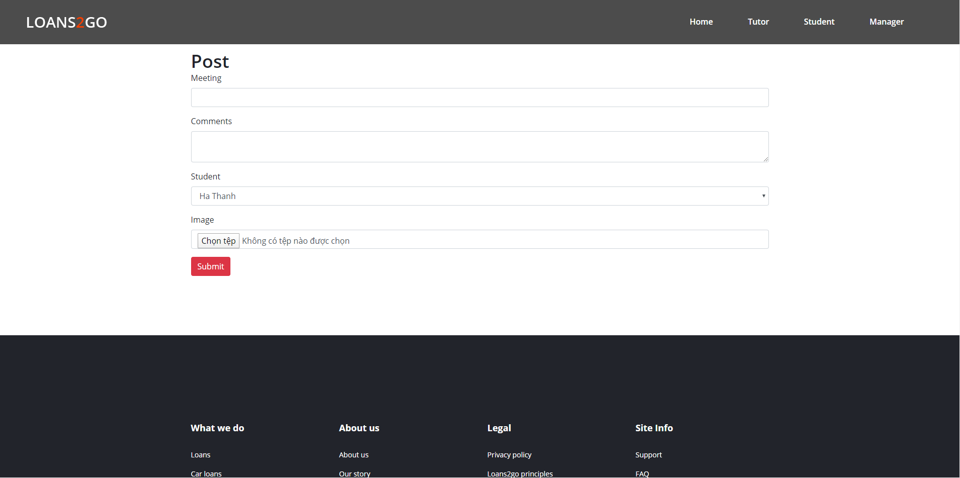

**3 Admin**

1. Student management

Wireframe:

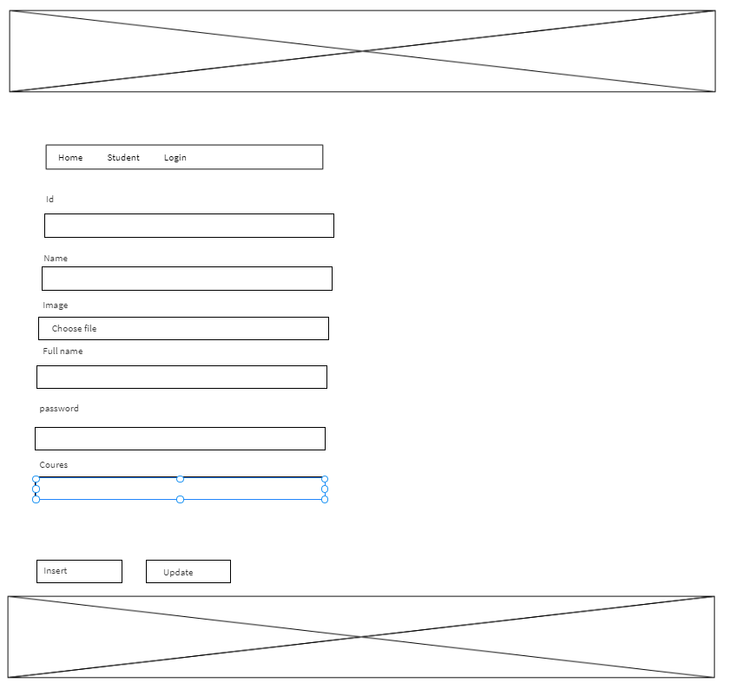

Reality:

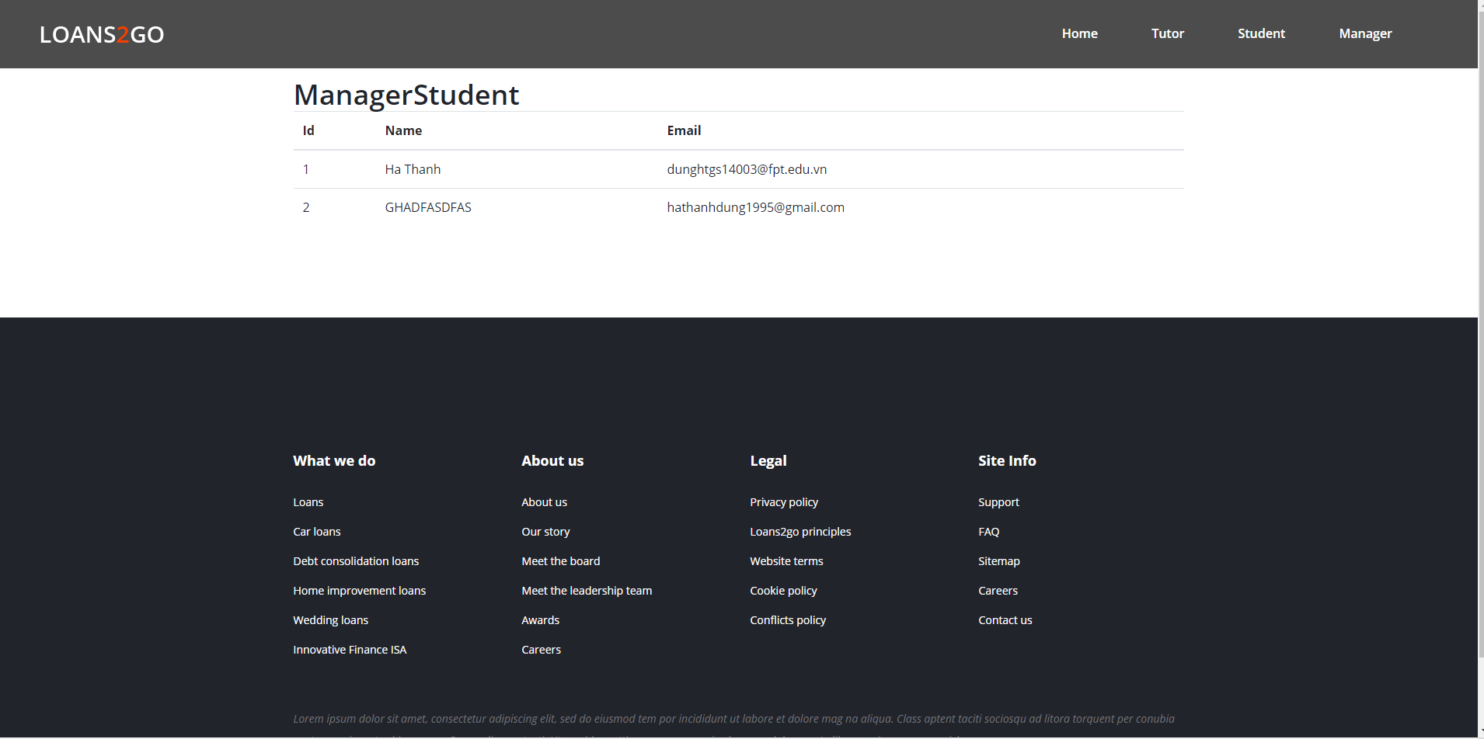

1. Decentralizing teachers and students

Wireframe:

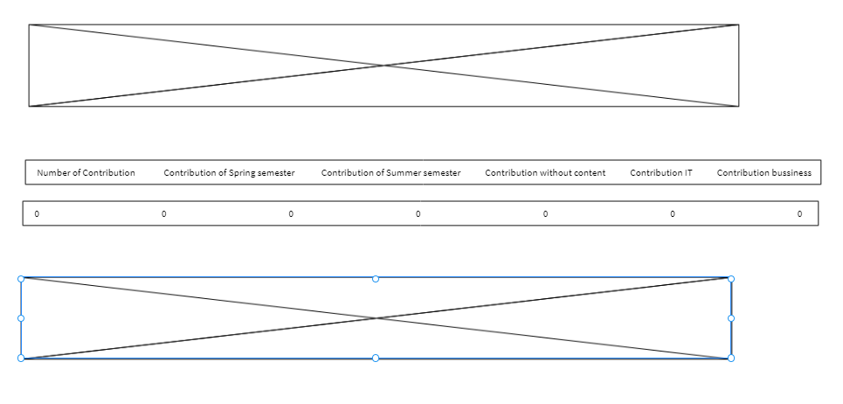

Reality:

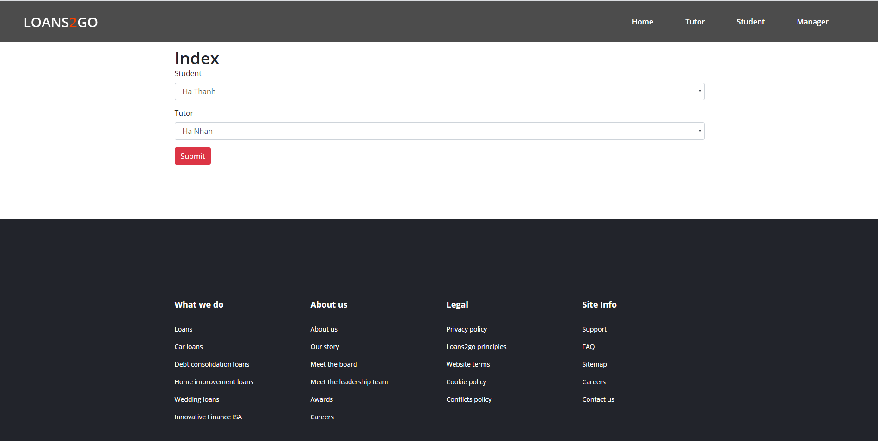

Evaluation:

Compared to the description in the Wireframes, the design after completion has a design that closely resembles what the whole group has imagined about the application. Although this is an eye-catching design, it seems to me that its functions still meet the requirements set out in Sprints.

# 4/ Testing

## Test plan

|  |  |  |  |
| --- | --- | --- | --- |
| **No** | **Test function** | **Description** | **Status** |
| 1 | Login | Student login, tutor login, admin login | Pass |
| 2 | Log out | Student logout , tutor logout, admin logout | Pass |
| 3 | System for communicating and exchanging information between teacher and student | Chat system, email system.  We try to chat and communicating and exchanging information between teacher and student. | Pass |
| 4 | System for organizing meetings between teacher and student | Teamview, meeting online class, call system.  We try to test organizing meetings between teacher and student | Pass |
| 5 | uploading documents  for student | Upload document system, we try to test uploading documents for student | Pass |
| 6 | uploading documents  for tutor | Upload document system, we try to test uploading documents for tutor | Pass |
| 7 | Student email system | Test send email for tutor | Pass |
| 8 | blogging system for student and teacher | Test upload blog and document for tutor and student | Pass |
| 9 | Personal calendar for tutor | Test create personal calendar for tutor, edit and delete it | Pass |
| 10 | Tutor email system | Test send email for student and admin | Pass |
| 11 | Student system of review of resources | Feedback test for admin or tutor | Pass |
| 12 | Tutor system of review of system | Feedback test for admin | Pass |
| 13 | Admin Authorised staff | Test Authorised staff will have access to the dashboards of other staff, and to individual dashboards for students. | Pass |
| 14 | data is accessed from the university MIS system | Student and staff data is accessed from the university MIS system. The maintenance of this is outside the scope of this project. | Pass |
| 15 | Manage tutor | Admin can assign rights to tutors and cancel their rights for students | Pass |
| 16 | Manage email system | Students and tutors will receive notification emails if there is a change in student or tuto | Pass |
| 17 | Admin allocate student and tutor | Admin can allocate a large number of students at the same time to 1 teacher | Pass |
| 18 | interface must be suitable for mobile phones, tablets, desktops | Test interface of application on mobile phones, tablets, desktops | Pass |

## 5/ Evaluation:

## Challenges:

Because it is the first time developing a project in a group model and using Scrum for the first time, there are many difficulties such as not focusing on large functions, difficult functions and no workarounds, and members without. Experience in Vietnamese interface design. However, all the goals are completed, all the functions according to the requirements are implemented, but still limited in terms of interface because the group does not have a designer. This project has a number of deadlines and takes a lot longer than expected for the whole project.

After completing the website, I realized that our application has some of the following weaknesses:

## System weaknesses:

* Student can’t comment in blog of themself or their tutor
* Student can’t contact with others student
* Tutor can’t get feedback from admin

## System Strengths

* Our application can be handles almost requirement for student, tutor and admin
* This application can help student and tutor can contact with each other well
* Admin can manage all users and roles, admin can be view statistical analysis and manage all course.
* All report can be download by Zip file.
* Each kind of account have role which are setup by admin and it just seen what admin want they seen.

## Learning outcomes.

After completing this project, I learned a lot about teamwork, improved communication skills, ability to negotiate, criticize and engage people, it also helped me increase my ability to predict and solve problems. Scrum agile techniques are a very good model for teamwork and it helps everyone on the team to work effectively and quickly as planned. To work well, a team needs to divide roles clearly, as well as constantly exchange information with each other, which helps to ensure the progress of the work and improve product quality.